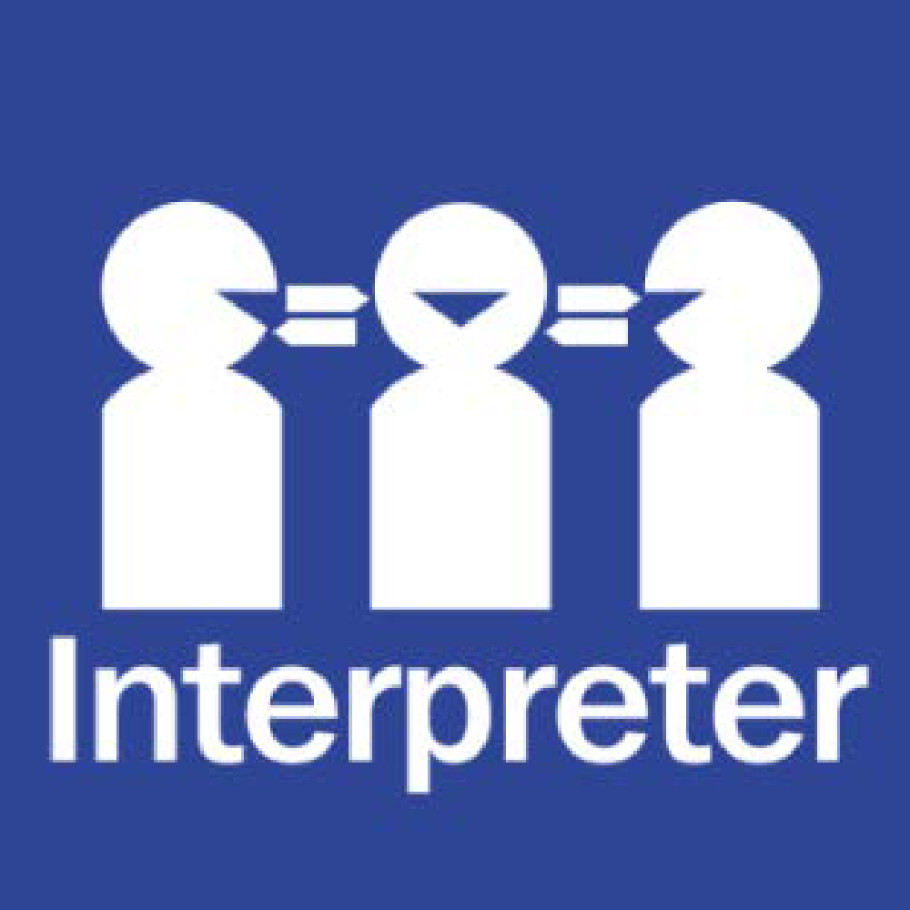
STUDENT WELLBEING AND ENGAGEMENT POLICY
Help for non-English speakers
If you need help to understand the information in this policy please contact Sydenham Primary School’s administration on 9361 5300.

PURPOSE
The purpose of this policy is to ensure that all students and members of our school community understand:
- our commitment to providing a safe and supportive learning environment for students
- expectations for positive student behaviour
- support available to students and families
- our school’s policies and procedures for responding to inappropriate student behaviour.
Sydenham Primary School is committed to providing a safe, secure and stimulating learning environment for all students. We understand that students reach their full potential only when they are happy, healthy and safe, and that a positive school culture, where student participation is encouraged and valued, helps to engage students and support them in their learning. Our school acknowledges that student wellbeing and student learning outcomes are closely linked.
The objective of this policy is to support our school to create and maintain a safe, supportive and inclusive school environment consistent with our school’s values.
SCOPE
This policy applies to all school activities, including camps and excursions.
CONTENTS
- School profile
- School values, philosophy and vision
- Wellbeing and engagement strategies
- Identifying students in need of support
- Student rights and responsibilities
- Student behavioural expectations and management
- Engaging with families
- Evaluation
POLICY
- School profile
Sydenham Primary School was established in 2026 as the result of the demerger of Sydenham-Hillside Primary School. It is located approximately 30 kilometres northwest of Melbourne’s CBD on the traditional lands of the Wurundjeri People. We currently have 478 students enrolled at our school from Foundation to Year 6 and 67 school staff members.
Sydenham Primary School is culturally diverse, with 44% of families having a language background other than English (LOTE), our largest LOTE group is Punjabi. We are proud of our diverse and inclusive school community.
Our facilities include learning buildings, STEAM building, administration building, gymnasium and hardcourts. Our school is next to the Sydenham Campus of Copperfield College, and we are surrounded by a supportive local community. Most students who attend our school live locally and tend to walk or ride their bike to school. Sydenham Primary School has developed close ties to the local community and enjoys support from our local shops and community services.
Sydenham Primary School offers a comprehensive and engaging curriculum program aligned with the Victorian Curriculum F–10, inclusive of Levels A–D. This ensures that all students, regardless of their starting point, can access a rich and differentiated learning experience that promotes growth in academic knowledge, critical thinking, creativity, and personal development.
We pride ourselves on setting high standards for students and staff and our vision underpins the schools focus on educating our students for the future. We strive to provide a nurturing and challenging environment that empowers students to reach their personal best, both academically and socially.
- School values, philosophy and vision
Sydenham Primary School’s Statement of Values and School Philosophy is integral to the work that we do and is the foundation of our school community. Our values are embedded in our daily interactions and the culture of our school.

Vision

Our school values of Respect, Responsibility, Safety and Learning are an integral part to all learning programs at Sydenham Primary School. The values continued to be embedded in our daily interactions and the culture of the school. These values have been displayed, articulated, and explicitly taught as a part of classroom practice and are recognised during school assemblies and promoted through the SWPBS token system.

Mission

Sydenham Primary School builds resilient, kind and inclusive individuals who value their education and empowers them to follow their life passions.

Objective

Our school’s objectives are considered as part of the 4 yearly strategic planning process and reflected in the goals listed in our current School Strategic Plan (SSP). We also develop an Annual Implementation Plan to operationalise the goals and key improvement strategies contained in our SSP.

Values
Sydenham Primary School’s values are Respect, Responsibility, Safety and Learning
Our school values, philosophy and vision guide our organisational leadership, governance, and culture to ensure that child safety and wellbeing are embedded in our school’s daily practices.

- Wellbeing and engagement strategies
Sydenham Primary School has developed a range of strategies to promote engagement, positive behaviour, equality and respectful relationships for all students in our school. We acknowledge that all students have individual social, emotional and/or educational needs at school, and that the needs of students will change over time as they grow and learn.
A summary of the universal (whole of school), targeted (year group specific) and individual engagement strategies used by our school is included below:
Universal
- high and consistent expectations of all staff, students and parents and carers
- prioritise positive relationships between staff and students, recognising the fundamental role this plays in building and sustaining student wellbeing
- creating a culture that is inclusive, engaging and supportive and that embraces and celebrates diversity and empowers all students to participate and feel value
- welcoming all parents/carers and being responsive to them as partners in learning
- analysing and being responsive to a range of school data such as attendance, Attitudes to School Survey, parent survey data, student management data (Sentral) and school level assessment data
- teachers at Sydenham Primary School use the Victorian Teaching and Learning Model (VTLM 2.0) as a framework to deliver an explicit, common and shared model of instruction. This ensure that evidenced-based, high yield teaching practices are incorporated into all lessons
- teachers at Sydenham Primary School adopt a broad range of teaching and assessment approaches to effectively respond to the diverse learning styles, strengths and needs of our students and follow the standards set by the Victorian Institute of Teaching
- our school’s Statement of Values and School Philosophy are incorporated into our curriculum and promoted to students, staff and parents so that they are shared and celebrated as the foundation of our school community
- carefully planned transition programs to support students moving into different stages of their schooling
- positive behaviour and student achievement is acknowledged in the classroom, and formally in school assemblies and in communication to parents/carers and the community
- monitor student attendance and implement attendance improvement strategies at a whole school, cohort and individual level
- creating multiple means of participation and empowerment for students in school decision-making, events and activities, such as through the Junior School Council, student surveys and other informal forums. Students are also encouraged to speak with their teachers, PLC Leaders, the Wellbeing Team, Assistant Principals and Principal whenever they have any questions or concerns
- our staff are committed to referring any student in need to the Wellbeing Team. Students are welcome to approach Classroom Teachers to discuss a particular issue if they may need support of any kind. We are proud to have an ‘open door’ policy where students and staff are partners in learning
- we engage in School Wide Positive Behaviour Support with our staff and students, which includes resources such as:
  - Respectful Relationships
  - Bully Stoppers
  - Safe Schools
  - Zones of Regulation
  - SWPBS lessons and matrix
  - Learning to learn/start up program
  - Wellbeing response guide
- a child safe culture is championed and modelled at all levels of the school from the top down and bottom up. Our Code of Conduct provides guidelines for staff and volunteers on expected behavioural standards and responsibilities. Risk management strategies focus on preventing, identifying and mitigating risks to children and young people
- supporting our staff to participate in the Community Understanding and Safety Training (CUST), which strengthens the capability of school staff to build more culturally inclusive practices, including embedding Aboriginal perspectives in the curriculum, and connecting with Aboriginal Community to support ongoing learning and partnership
- implementing restorative approaches for conflict resolution and problem-solving, emphasising dialogue, empathy, and repairing harm within relationships
- organising regular events, such as assemblies, celebrations, or themed days, to strengthen connections among students, staff, and families
- we encourage strong friendships and peer support in the school to ensure a sense of belonging through class buddies, lunchtime clubs, start-up programs, and social stories implementing our whole school approach to Respectful Relationships
- promoting physical activity through structured recess activities, sports programs, and opportunities for movement breaks during class time
- acknowledge that every student can learn and has the right to learn
- focus on collaboration amongst staff, with support services and families
- focus on professional growth and risk-taking to help staff build skills in inclusive practice
- expect that inclusion is everybody’s business
- acknowledge the individual needs of all children
- celebrate the strengths of every student
- identify and eliminate barriers to inclusion
- foster a culture where children themselves are welcoming and respectful of students with disabilities.
Targeted
- each year level has a PLC Leader and Assistant Principal responsible for their year, who monitors the health and wellbeing of students in their year, and act as a point of contact for students who may need additional support
- our school creates a learning environment for all students that acknowledges, respects and values Koorie culture. We connect all Koorie students with a Koorie Engagement Support Officer and ensure each Koorie student has an Individual Education Plan. Koorie Engagement Support Officers provide additional cultural and educational experiences for our Koorie students as part of our Action Plan for Aboriginal Learning, Wellbeing and Safety
- our English as an Additional Language (EAL) students are supported through our EAL program, and all Cultural and Linguistically Diverse (CALD) students are supported to feel safe and included in our school. This includes liaising with our Leading Teacher (EAL) as part of their transition to Sydenham Primary School. Sociolinguistic profiles are also developed for newly arrived students to best support their transition to our school
- we provide a positive and respectful learning environment for our students who identify as LGBTIQA+ and follow the Department’s policy on LGBTIQA+ Student Support Policy
- all students in Out-of-Home Care are supported in accordance with the Department’s policy on Supporting Students in Out-of-Home Care, including being appointed a Learning Mentor, having an Individual Education Plan and a Student Support Group, and being referred to Student Support Services for an Educational Needs Assessment if required
- students with a disability are supported to be able to engage fully in their learning and school activities in accordance with the Department’s policy on Students with Disability, such as through reasonable adjustments to support access to learning programs, consultation with families and where required, Student Support Groups and Individual Education Plans
- the Wellbeing team undertake health promotion and social skills development in response to needs identified by student wellbeing data, classroom teachers or other school staff each year
- staff apply a trauma-informed approach to working with students who have experienced trauma
- developing targeted transition programs for students moving from one grade level to another (e.g., from kindergarten to primary school or from primary to secondary school) to support their social and emotional adjustment and ensure a smooth transition.
Sydenham Primary School implements a range of strategies that support and promote individual engagement. These include:
- building constructive relationships with students at risk or students who are vulnerable due to complex individual circumstances
- meeting with student and their parent/carer to talk about how best to help the student engage with school
- developing an Individual Education Plan, Attendance Improvement Plan and/or Positive Behaviour Plan
- utilising additional resources available for students supported under Disability Inclusion
- considering if any environmental changes need to be made, for example changing the classroom set up, providing sensory support
- referring the student to:
  - our school-based Wellbeing Team
  - Student Support Services
  - appropriate external supports such as council-based youth and family services, other allied health professionals, headspace, child and adolescent mental health services or Orange Door
  - LOOKOUT Education Support Centres
  - re-engagement programs such as Navigator.
Where necessary our school will support the student’s family to engage by:
- being responsive and sensitive to changes in the student’s circumstances and health and wellbeing
- collaborating, where appropriate and with the support of the student and their family, with any external allied health professionals, services or agencies that are supporting the student
- monitoring individual student attendance and developing an Attendance Improvement Plan in collaboration with the student and their family
- engaging with our regional Koorie Engagement Support Officers (KESOs) who ensure culturally responsive support and resources are available for indigenous students
- running regular Student Support Group meetings for all students:
  - with a disability
  - in Out-of-Home Care
  - and with other complex needs that require ongoing support and monitoring.

- Identifying students in need of support
Sydenham Primary School is committed to providing the necessary support to ensure our students are supported intellectually, emotionally and socially. The Wellbeing Team plays a significant role in developing and implementing strategies to help identify students in need of support and enhance student wellbeing. Sydenham Primary School utilises the following information and tools to identify students in need of extra emotional, social or educational support:
- personal, health and learning information gathered upon enrolment and while the student is enrolled
- attendance records
- academic performance
- observations by school staff such as changes in engagement, behaviour, self-care, social connectedness and motivation
- Sentral data
- general health wellbeing data
- attitude and behaviour data
- engagement with families
- referral process for the Wellbeing Team
- handover information between year level teachers
- Student Support Groups (SSGs) and Individual Education Plans (IEPs).

- Student rights and responsibilities
All members of our school community have a right to experience a safe and supportive school environment. We expect that all students, staff, parents and carers treat each other with respect and dignity. Our school’s Statement of Values and School Philosophy highlights the rights and responsibilities of members of our community.
Students have the right to:
- participate fully in their education
- feel safe, secure and happy at school
- have a voice regarding their learning
- equal opportunities regardless of their gender, age, impairments, sexual orientation, physical features, religious beliefs or personal associations in all areas of learning
- celebrate and share their culture with the school community
- learn in a safe and secure environment where they can fully develop their knowledge and skills free from violence, racism, discrimination, intimidation, harassment, bullying or cyber-bullying
- participate fully in the school’s educational program regardless of any intellectual and/or physical disabilities
- receive reasonable assistance to resolve school-related concerns (e.g. academic and behavioural)
- receive ongoing communication and feedback about their progress
- talk to teachers on issues that negatively impact their health and wellbeing
- showcase their talents and skills in extracurricular activities
- achieve their goals.
Students have the responsibility to:
- participate fully in their educational program
- display positive behaviours that demonstrate respect for themselves, their peers, their teachers and members of the school community
- respect the right of others to learn
- follow the Code of Conduct, staff instructions and uniform requirements
- strive to uphold the values and principles outlined in our school’s Statement of Values and School Philosophy
- take responsibility for their own behaviour and learning
- display positive behaviours, including courtesy, care and respect for the rights of peers, teachers and all members of the school community
- care for the school environment
- attend school regularly and participate fully in learning programs
- develop into independent learners who set and achieve learning goals and manage resources effectively
- care for their own wellbeing and their property (e.g. iPad, hats, bags, clothing, and lunchboxes).
Students who may have a complaint or concern about something that has happened at school are encouraged to speak to their parents or carers and approach a trusted teacher or a member of the school leadership team. Further information about raising a complaint or concern is available in our Complaints Policy.
- Student behavioural expectations and management
Sydenham Primary School is committed to the safety and wellbeing of children and young people. Our school community recognises the importance of, and a responsibility for, ensuring our school is a safe, supportive and enriching environment which respects and fosters the dignity and self-esteem of children and young people, and enables them to thrive in their learning and development.
Behavioural expectations of students are grounded in our school’s Statement of Values and School Philosophy.
Violence, bullying, and other offensive and harmful behaviours such as racism, harassment and discrimination are not tolerated and are managed in accordance with this policy and our Bullying Prevention Policy.
When a student acts in breach of the behaviour standards of our school community, Sydenham Primary School will institute a staged response, consistent with the Department’s policies on behaviour, discipline and student wellbeing and engagement. Where appropriate, parents/carers will be informed about the inappropriate behaviour and the disciplinary action taken by teachers and other school staff.
Disciplinary measures may be used as part of a staged response to inappropriate behaviour in combination with other engagement and support strategies to ensure that factors that may have contributed to the student’s behaviour are identified and addressed. Disciplinary measures at our school will be applied fairly and consistently. Students will always be provided with an opportunity to be heard.
Disciplinary measures that may be applied include:
- warning a student that their behaviour is inappropriate
- teacher-controlled consequences such as moving a student in a classroom or other reasonable and proportionate responses to misbehaviour
- withdrawal of privileges
- referral to the Assistant Principal
- restorative practices
- detentions
- behaviour reviews
- suspension
- expulsion.
Suspension, expulsion and restrictive interventions are measures of last resort and may only be used in situations consistent with Department policy, available at:
- https://www2.education.vic.gov.au/pal/suspensions/policy
- https://www2.education.vic.gov.au/pal/expulsions/policy
- https://www2.education.vic.gov.au/pal/restraint-seclusion/policy
In line with Ministerial Order 1125, no student aged 8 or younger will be expelled without the approval of the Secretary of the Department of Education.
The Principal of Sydenham Primary School is responsible for ensuring all suspensions and expulsions are recorded on CASES21.
Corporal punishment is prohibited by law and will not be used in any circumstance at our school.
- Engaging with families
Sydenham Primary School values the input of parents and carers, and we strive to support families to engage in their child’s learning and build their capacity as active learners. We aim to be partners in learning with parents and carers in our school community.
We work hard to create successful partnerships with parents and carers by:
- ensuring that all parents/carers have access to our school policies and procedures, available on our school website
- maintaining an open, respectful line of communication between parents/carers and staff, supported by our Communicating with School Staff Policy
- communicating with families through our school newsletter, Sentral, class dojo and Facebook
- providing parent/carer volunteer opportunities so that families can contribute to school activities
- involving families with homework and other curriculum-related activities
- involving families in school decision making
- coordinating resources and services from the community for families
- including families in SSG and developing individual plans for students
- offering multilingual communication and resources to ensure information is accessible
- respecting and valuing cultural differences and practices in our interactions.

- Evaluation
Sydenham Primary School collects data each year to understand the frequency and types of wellbeing issues that are experienced by our students so that we can measure the success or otherwise of our school-based strategies and identify emerging trends or needs.
Sources of data assessed on an annual basis include:
- student survey data
- incidents data
- school reports
- parent survey
- case management
- CASES21, including attendance and absence data
- Student Online Case System (SOCS).
Sydenham Primary School regularly monitors available data dashboards to ensure any wellbeing or engagement issues are acted upon in a timely manner and any intervention occurs as soon as possible.
COMMUNICATION
This policy will be communicated to our school community in the following ways
- available publicly on our school’s website
- included in staff induction processes
- included in transition and enrolment packs
- included in student diaries so that it is easily accessible to parents, carers and students
- included as annual reference in our school newsletter
- made available in hard copy from school administration upon request
Our school will also ensure it follows the mandatory parent/carer notification requirements with respect to suspensions and expulsions outlined in the Department’s policies at:
- Suspension process
- Expulsions - Decision
FURTHER INFORMATION AND RESOURCES
The following Department of Education policies and resources are relevant to this Student Wellbeing and Engagement Policy:
- Attendance
- Student Engagement
- Child Safe Standards
- Koorie Education Policy
- Supporting Students in Out-of-Home Care
- Students with Disability
- LGBTIQA+ Student Support
- Behaviour - Students
- Suspensions
- Expulsions
- Restraint and Seclusion
- Preventing and Addressing Racism in Schools
- Multicultural education programs and resources
The following school policies are also relevant to this Student Wellbeing and Engagement Policy:
- Communicating with School Staff Policy
- Action Plan Aboriginal Learning, Wellbeing and Safety
- Child Safety and Wellbeing Policy
- Bullying Prevention Policy
- Inclusion and Diversity Policy
- Statement of Values and School Philosophy
- Complaints Policy
- Duty of Care Policy

POLICY REVIEW AND APPROVAL
Policy last reviewed | December 2025
Consultation | Consultation with students, staff and parents/carers and/or School Council to take place in Term 1, 2026 (or as soon as the School Council is appointed)
Approved by | Principal
Next scheduled review date | Decemeber, 2026 – to ensure ongoing relevance and continuous improvement, this policy will be reviewed every 1-2 years thereafter*.
*The Student Wellbeing and Engagement Policy will be reviewed earlier if a significant incident occurs or due to legislative changes.

