INCLUSION AND DIVERSITY POLICY
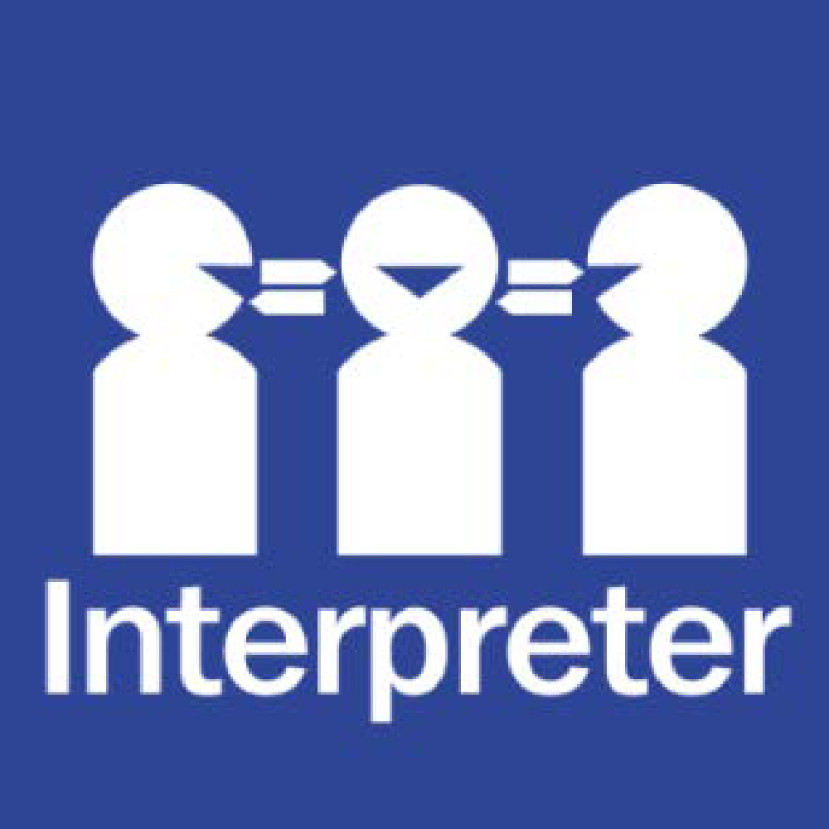
(includes Equal Opportunity and Sexual Harassment)
Help for non-English speakers
If you need help to understand the information in this policy, please contact Sydenham Primary School’s administration on 9361 5300.
PURPOSE
The purpose of this policy is to explain Sydenham Primary School’s commitment to making sure every member of our school community, regardless of their background or personal attributes, is treated with respect and dignity. This policy should be read alongside the following Department of Education policies:
- Equal Opportunity and Human Rights - Students
- For staff, the Respectful Workplaces policies (including Equal Opportunity and Anti-Discrimination, Sexual Harassment and Workplace Bullying) as these whole of Department policies apply to all staff at Sydenham Primary School.
POLICY

Definitions
Personal attribute: a personal characteristic that is protected by State or Commonwealth anti-discrimination legislation. These include: race, disability, sex, sexual orientation, gender identity, religious belief or activity, political belief or activity, age, intersex status, physical features, pregnancy, carer and parental status, breastfeeding, marital or relationship status, lawful sexual activity, employment activity, industrial activity, expunged homosexual conviction or personal association with anyone who is identified with reference to any protected attribute.
Direct discrimination: unfavourable treatment because of a person’s protected attribute.
Indirect discrimination: imposing an unreasonable requirement, condition or practice that disadvantages a person or group of people with a protected attribute.
Sexual harassment: unwelcome conduct of a sexual nature towards another person which could reasonably be expected to make that other person feel offended, humiliated or intimidated. It may be physical, verbal, visual or written.
Disability harassment: an action taken in relation to the person’s disability that is reasonably likely, in all the circumstances, to humiliate, offend, intimidate or distress the person.
Vilification: conduct that incites hatred towards or revulsion or severe ridicule of a person or group of people on the basis of their race or religion.
Victimisation: subjecting a person or threatening to subject them to detrimental treatment because they (or their associate) has made an allegation of discrimination or harassment on the basis of a protected attribute (or asserted their rights under relevant policies or law).

Inclusion and diversity
Sydenham Primary School strives to provide a safe, inclusive and supportive school environment which values the human rights of all students and staff.
Sydenham Primary School is located on the traditional lands of the Wurundjeri People. Our school is culturally diverse, with 44% of families having a language background other than English (LOTE), our largest LOTE group is Punjabi. We are proud of our diverse and inclusive school community. We celebrate different cultures and backgrounds and create a space for students to be authentically themselves. We are proud of our diversity and inclusive school community.
Sydenham Primary School is committed to creating a school community where all members of our school community are welcomed, accepted and treated equitably and with respect regardless of their backgrounds or personal attributes such as race, language, religious beliefs, gender identity, disability or sexual orientation so that they can participate, achieve and thrive at school.
Sydenham Primary School acknowledges and celebrates the diversity of backgrounds and experiences in our school community, and we will not tolerate behaviours, language or practices that label, stereotype or demean others. At Sydenham Primary School we value the human rights of every student, and we take our obligations under anti-discrimination laws and the Charter of Human Rights and Responsibilities seriously.
Sydenham Primary School:
- actively nurtures and promotes a culture where everyone is treated with respect and dignity
- ensures that students are not discriminated against (directly or indirectly) and where necessary, are reasonably accommodated to participate in their education and school activities including school sports, concerts, incursions and excursions on the same basis as their peers
- acknowledges and responds to the diverse needs, identities and strengths of all students
- encourages empathy and fairness towards others
- challenges stereotypes that promote prejudicial and biased behaviours and practices
- contributes to positive learning, engagement and wellbeing outcomes for students
- responds to complaints and allegations appropriately and ensures that students are not victimised.
In addition, Sydenham Primary School is committed to fostering an inclusive environment that celebrates diversity by:
- implementing measures to empower our school community to identify, report and address inappropriate and harmful behaviours such as racism, homophobia and other forms of discrimination or harassment
- we provide a positive and respectful learning environment for our students who identify as LGBTIQA+ and follow the Department’s policy on LGBTIQA+ Student Support Policy
- our English as an Additional Language (EAL) students are supported through our EAL program, and all Cultural and Linguistically Diverse (CALD) students are supported to feel safe and included in our school. Sociolinguistic profiles are also developed for newly arrived students to best support their transition to our school
- students with a disability are supported to be able to engage fully in their learning and school activities in accordance with the Department’s policy on Students with Disability, such as through reasonable adjustments to support access to learning programs, consultation with families and where required, Student Support Groups and Individual Education Plans
- recognise key events including Harmony Day, NAIDOC week, Reconciliation week and key multicultural days
- Curriculum planning embeds Aboriginal perspectives and actively plans for incursions that are related to Aboriginal culture across the school
- Recognising and celebrating culturally significant events with families and providing parent volunteer opportunities to all families – enabling students to be involved in various cultural experiences as part of their learning
- acknowledge that every student can learn and has the right to learn
- focus on collaboration amongst staff, with support services and families
- focus on professional growth and risk-taking to help staff build skills in inclusive practice
- expect that inclusion is everybody’s business
- acknowledge the individual needs of all children
- celebrate the strengths of every student
- identify and eliminate barriers to inclusion
- foster a culture where children themselves are welcoming and respectful of students with disabilities.
Bullying, unlawful discrimination, harassment, vilification and other forms of inappropriate behaviour targeting individuals or groups because of their personal attributes is not tolerated at Sydenham Primary School. We take appropriate measures, consistent with our Student Wellbeing and Engagement and Bullying Prevention policies to respond to students who demonstrate these behaviours at our school.
Students who may have experienced or witnessed this type of behaviour are encouraged to speak up and to let their teachers, parents or carers know about those behaviours to ensure that inappropriate behaviour can be addressed.
Reasonable adjustments for students with disabilities
Sydenham Primary School also understands that it has a legal obligation to make reasonable adjustments to accommodate students with disabilities. A reasonable adjustment is a measure or action taken to assist students with disabilities to participate in their education on the same basis as their peers in accordance with the Department’s Students with Disability policy. Reasonable adjustments will be made for students with disabilities in consultation with the student, their parents or carers, their teachers and if appropriate, their treating practitioners. Our school may consult through Student Support Group (SSG) processes and in other less formal ways. For more information about support available for students with disabilities and communicating with us in relation to a student’s disability, please refer to our school’s Student Wellbeing and Engagement policy or contact the Assistant Principal for further information.
COMMUNICATION
This policy will be communicated to our school community in the following ways:
- included in staff induction processes and staff training
- available publicly on our school’s website
- included in staff handbook
- discussed at annual staff briefings/meetings
- included in transition and enrolment packs
- reminders in our school newsletter
- hard copy available from school administration upon request
RELATED POLICIES AND RESOURCES
For staff, please see the Department’s Equal Opportunity and Anti-Discrimination Policy, Sexual Harassment Policy and Workplace Bullying Policy which apply to all staff working at our school.
Other relevant Department policies and resources on the Department’s Policy and Advisory Library are:
- Equal Opportunity and Human Rights - Students
- Students with Disability
- Koorie Education
- Teaching Aboriginal and Torres Strait Islander Culture
- Safe Schools
- Supports and Services
- Preventing and Addressing Racism in schools
- Program for Students with Disabilities
Related Policies:
- Child Safety and Wellbeing Policy
- Statement of Values and School Philosophy
- Bullying Prevention Policy
- Student Wellbeing & Engagement Policy
Other resources:
- Refugee Education Support Initiatives (RESI)
- Student Leaders for Multicultural Inclusion
- Languages and Multicultural Education Resource Centre (LMERC)
- Schools - culturally safe environments guidance

POLICY REVIEW AND APPROVAL
Policy last reviewed | December 2025
Approved by | Principal
Next scheduled review date | July 2029 – to ensure ongoing relevance and continuous improvement, this policy will be reviewed every 3 – 4 years thereafter

